Environment setup

For linux

Python Installation

* **ubuntu version 16.10**

$ sudo apt-get update

$ sudo apt-get install python3.8

* **For other versions of ubuntu**

$ sudo apt-get install software-properties-common

$ sudo add-apt-repository ppa:deadsnakes/ppa

$ sudo apt-get update

$ sudo apt-get install python3.8

Anaconda Installation

1. Download Anaconda Installer for Linux – Click the link and

scroll till bottom of the page

<https://www.anaconda.com/products/individual>

2. Run below command

bash ~/Downloads/Anaconda3-2020.02-Linux-x86_64.sh

Note: If you did not download to your Downloads directory, replace ~/Downloads/ with the path to the file you downloaded.

3. The installer prompts you to click Enter to accept the default install location, CTRL-C to cancel the installation, or specify an alternate installation directory. If you accept the default install location, the installer displays “PREFIX=/home/<user>/anaconda<2 or 3>” and continues the installation. It may take a few minutes to complete.

Note: Default location is recommended.

4. The installer prompts “Do you wish the installer to initialize Anaconda3 by running conda init?” We recommend “yes”.

Note: If you enter “no”, then conda will not modify your shell scripts at all. In order to initialize after the installation process is done, first run

$ source <path to conda>/bin/activate

and then run,

$ conda init

For Windows

Python Installation

1. Download python exe or zip from the link <https://www.python.org/downloads/release/python-386/>
2. Unzip zip file in C:\Users\sharman\AppData\Local\Programs\Python\Python38

Or Click exe and you will get below screen. Click Install Now and follow the steps.

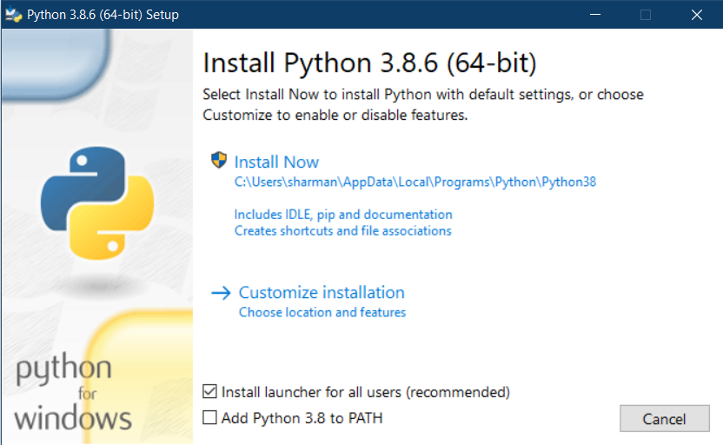

1. Add Python folder in PATH variable
2. [Right Click] Computer > Properties >Advanced System Settings > Environment Variables
3. Click [New] under "System Variable"
4. Variable Name: PY_HOME,
5. Value: C:\Users\sharman\AppData\Local\Programs\Python\Python38
6. Click [OK]
7. Locate the "Path" System variable and click [Edit]
8. Add the following to the existing variable: %PY_HOME%;
9. Click [OK] to close all the windows.

For more details follow this stackoverflow [link](https://stackoverflow.com/questions/3701646/how-to-add-to-the-pythonpath-in-windows-so-it-finds-my-modules-packages).

Anaconda Installation

1. Download Anaconda Installer for Windows – Click the link and

scroll till bottom of the page

<https://www.anaconda.com/products/individual>

1. Double click the installer to launch.
2. Click Next.
3. Read the licensing terms and click “I Agree”.
4. Select an install for “Just Me” unless you’re installing for all users (which requires Windows Administrator privileges) and click Next.
5. Select a destination folder to install Anaconda and click the Next button.
6. Choose whether to add Anaconda to your PATH environment variable. We recommend not adding Anaconda to the PATH environment variable, since this can interfere with other software. Instead, use Anaconda software by opening Anaconda Navigator or the Anaconda Prompt from the Start Menu.
7. Choose whether to register Anaconda as your default Python. Unless you plan on installing and running multiple versions of Anaconda or multiple versions of Python, accept the default and leave this box checked.

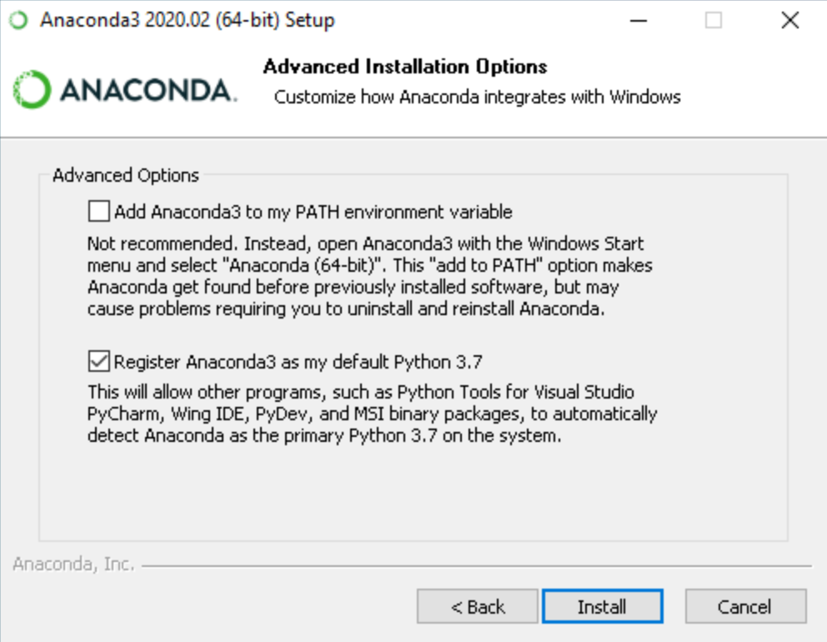

1. Click the Install button. If you want to watch the packages Anaconda is installing, click Show Details.
2. Click the Next button.

Refer [link](https://docs.anaconda.com/anaconda/install/linux/) for more details.

For MacOS

Python installation

1. Before installing Python, you’ll need to install GCC. GCC can be obtained by downloading Xcode, the smaller Command Line Tools (must have an Apple account) or the even smaller OSX-GCC-Installer package.

**Note:** If you already have Xcode installed, do not install OSX-GCC-Installer. In combination, the software can cause issues that are difficult to diagnose.

**Note:** If you perform a fresh install of Xcode, you will also need to add the commandline tools by running xcode-select --install on the terminal.

1. To install Homebrew run below command if already not there.

$ /bin/bash -c "$(curl -fsSL <https://raw.githubusercontent.com/Homebrew/install/master/install.sh>)"

1. Once you’ve installed Homebrew, insert the Homebrew directory at the top of your PATH environment variable. You can do this by adding the following line at the bottom of your ~/.profile file

export PATH="/usr/local/opt/python/libexec/bin:$PATH"

1. If you have OS X 10.12 (Sierra) or older use this line instead

export PATH=/usr/local/bin:/usr/local/sbin:$PATH

1. Install python

brew install python

Refer [link](https://docs.python-guide.org/starting/install3/osx/) for more details.

Anaconda installation

1. Download command line installer for python 3.7 from this [link.](https://www.anaconda.com/products/individual#macos)
2. Run bash ~/Downloads/Anaconda3-2020.02-MacOSX-x86_64.sh
3. The installer prompts “In order to continue the installation process, please review the license agreement.” Click Enter to view the license terms.
4. Scroll to the bottom of the license terms and enter yes to agree to them.
5. The installer prompts you to Press Enter to confirm the location, Press CTRL-C to cancel the installation or specify an alternate installation directory. If you confirm the default location, it will display PREFIX=/home/<user>/anaconda<2 or 3> and continue the installation.

Installation may take a few minutes to complete.

1. The installer prompts “Do you wish the installer to initialize Anaconda3 by running conda init?” We recommend “yes”.
2. If you enter “no”, then conda will not modify your shell scripts at all. In order to initialize after the installation process is done, first run source <path to conda>/bin/activate and then run conda init.

Refer [link](https://docs.anaconda.com/anaconda/install/mac-os/) for more details.